Lincense Key Updation-

Open Deployment Manager

Then click on open Control Panel

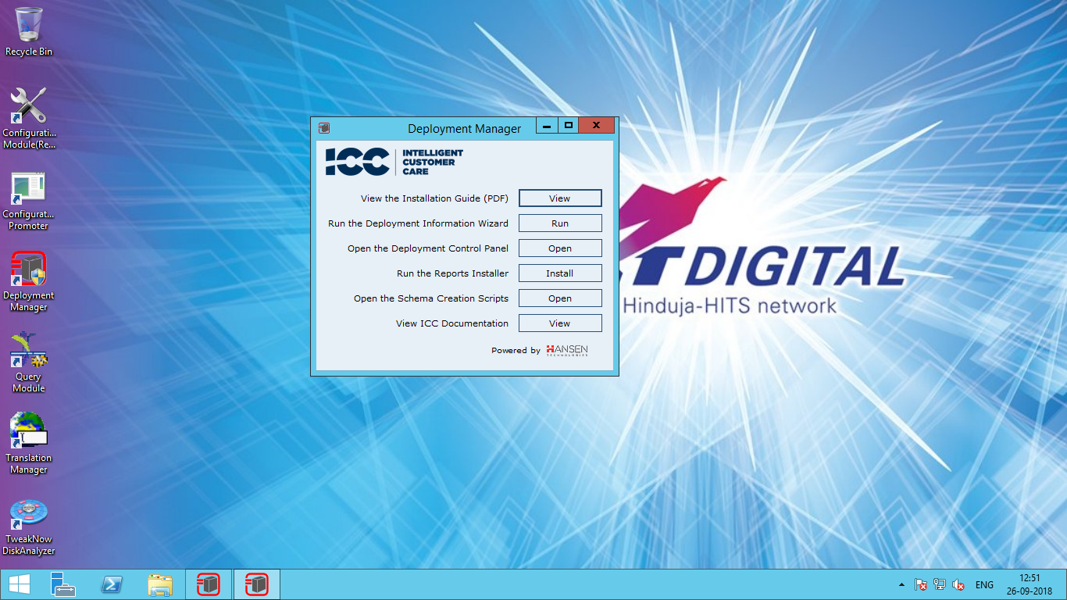

Then click on Help and click on About Deployment Manager

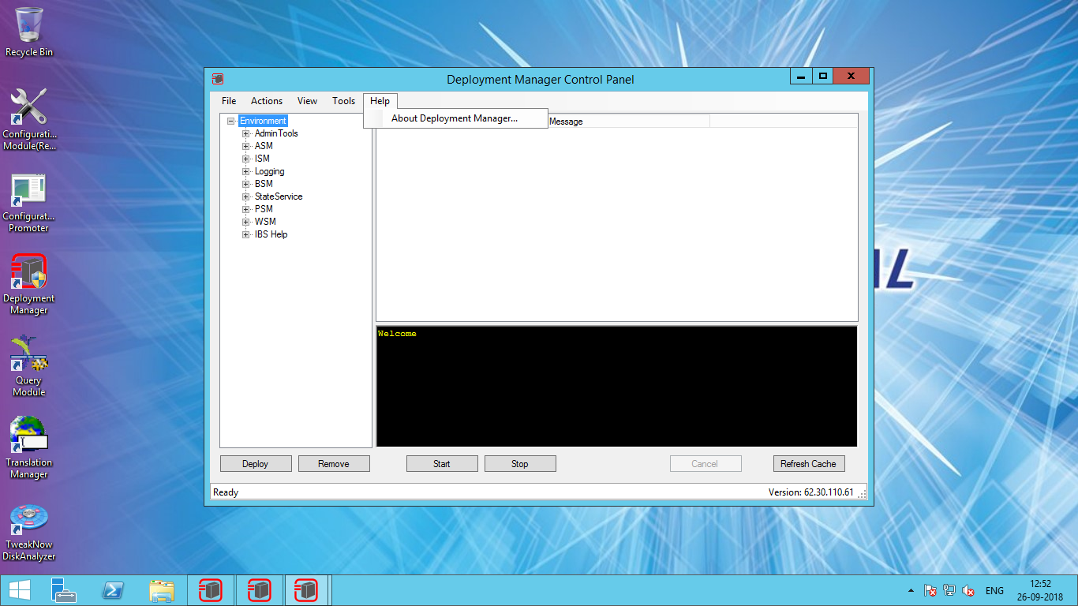

The click on change license key

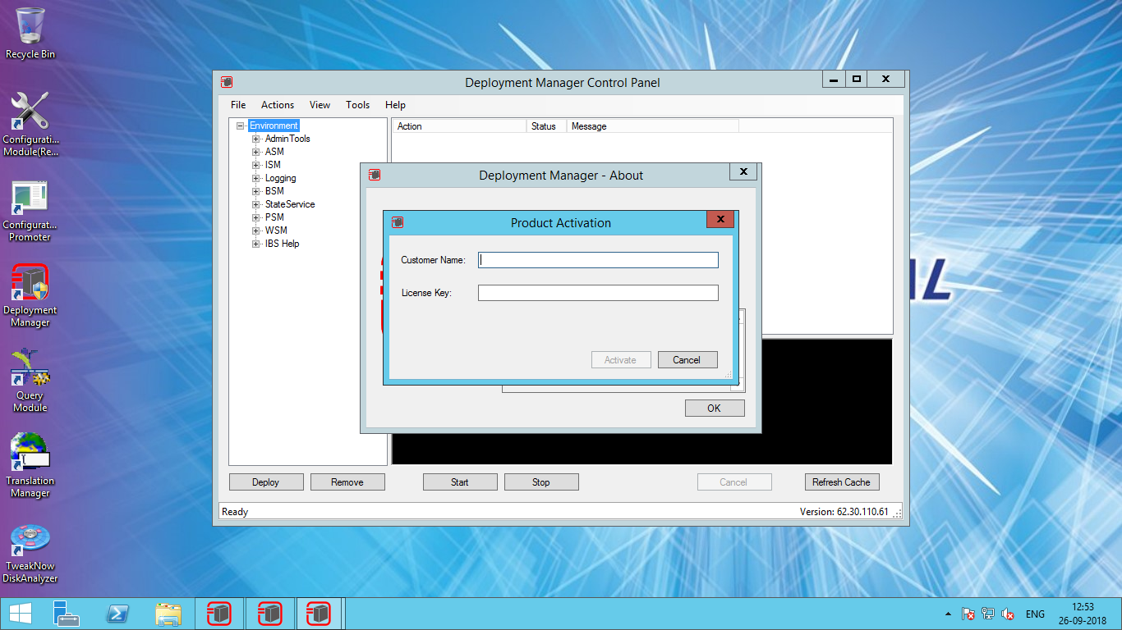

Then Enter customer name and license key